# Hotel

# Use-Case: Hotel Booking System

1. Brief Description

The Hotel Booking System use case was performed to test the whole hotel booking system functionality. This software is use by user for hotel services purposes in the hotel for example book a room or any other hotel services. Firstly, user can book a room and get a booking confirmation number which will need on check in time. After checked in the user can add other hotel services by choosing specific service. On check out user can pay the whole amount including extra services.

1. Actor

User

1. Pre-Conditions
   1. The main menu is displayed including room type information as Single, Double, Twin share.

* B: Book a Room
* C: Check In
* R: Record Service
* D: Check Out
* Q: Quit

Prompt to enter the one of the selected latter (B, C, R, D or Q).

1. Normal Flow

The use case begins when user type selected latter from the main menu.

|  |  |
| --- | --- |
| Actor | System |
|  | 1. Prompt to enter the one of the selected latter (B, C, R, D or Q). |
| 1. Type (B) for Book a Room. | 1. Prompt to enter phone number. |
| 1. Enter phone number | 1. Prompt to enter guest name. |
| 1. Enter guest name | 1. Prompt to enter guest address. |
| 1. Enter guest address | 1. Display the following :  * Display customer entered details. * Display room type options. * Prompt to enter room type selection. |
| 1. Enter selected room type | 1. Prompt to enter number of occupants. |
| 1. Enter number of occupants | 1. Prompt to enter arrival date  * Enter day (DD) * Enter month (MM) * Enter year (YYYY) |
| 1. Enter arrival date day/month/year accordingly | 1. Prompt to enter length of stay. |
| 1. Enter length of stay | 1. Display the cost and prompt to enter the credit card details as :  * Select credit card type from the options. * Enter credit card number. * Enter CCV number |
| 1. Enter credit card details accordingly | 1. Display following:  * Booking details including cost * Confirmation Number |
| 1. Hit <enter> to continue | 1. Booking Completed |
| **Display main menu again** | |
|  | 1. Prompt to enter the one of the selected latter (B, C, R, D or Q). |
| 1. Type (C) for Check in | 1. Prompt to enter confirmation number. |
| 1. Enter confirmation number | 1. Display following:  * Display booking details. * Prompt to confirm check in? (y/n) |
| 1. Enter (y) to confirm check in | 1. Display check in confirmed |
| 1. Hit <enter> to continue | 1. Checking in completed |
| **Display main menu again** | |
|  | 1. Prompt to enter the one of the selected latter (B, C, R, D or Q). |
| 1. Type (R) for record services | 1. Display following:  * Display services types * B: Bar Fridge * R: Restaurant * S: Room Service * Prompt to enter service type |
| 1. Enter service type | 1. Prompt to enter service cost |
| 1. Enter service cost | 1. Display Services details including cost |
| 1. Hit <enter> to continue | 1. Record service completed |
| **Display main menu again** | |
|  | 1. Prompt to enter the one of the selected latter (B, C, R, D or Q). |
| 1. Type (D) for check out | 1. Prompt to enter room number |
| 1. Enter room number | 1. Display following:  * Display booking details * Display service charges cost * Display total cost * Prompt to accept charges? (y/n) * Remove the room from the active booking list. |
| 1. Enter (y) to accept charges | 1. Display the cost and prompt to enter the credit card details. |
| 1. Enter credit card details | 1. Display debited amount. |
| 1. Hit <enter> to continue | 1. Display checking out completed. |
| **Display main menu again** | |

The use case ends.

1. Unsuccessful Flows

|  |  |
| --- | --- |
| **Display main menu again – Record service** | |
|  | 1. Prompt to enter the one of the selected latter (B, C, R, D or Q). |
| 1. Type (R) for record services | 1. Display following:  * Display services types * B: Bar Fridge * R: Restaurant * S: Room Service * Prompt to enter service type |
| 1. Enter service type | 1. Prompt to enter service cost |
| 1. Enter service cost | 1. Display following:  * Services details including cost * **Store cost value.** |
| 1. Hit <enter> to continue | 1. Record service completed |
| **Display main menu again – Checking out** | |
|  | 1. Prompt to enter the one of the selected latter (B, C, R, D or Q). |
| 1. Type (D) for check out | 1. Prompt to enter room number |
| 1. Enter room number | 1. Display following:  * Display booking details * Display service charges cost **$0.00** * Display total cost **$0.00** * Prompt to accept charges? (y/n) * **Remove the room from the active booking list.** |
| 1. Enter (y) to accept charges | 1. Display the cost and prompt to enter the credit card details. |
| 1. Enter credit card details | 1. Display debited amount **$0.00**. |
| 1. Hit <enter> to continue | 1. Display checking out completed. |

**5.1 First reported bug: Record services cost shows $0.00 on checking out**

**The normal flow is required to display the correct cost not the $0.00 at checking out.**

The usage of variable is not correct that is why the entered cost is not passing to the required method which could store the value and the unit testing result is also failed because of it.

**Unit test output:**

The test result is failed because of the buggy behaviour as the method does not store the value that is why expected and actual result is different.

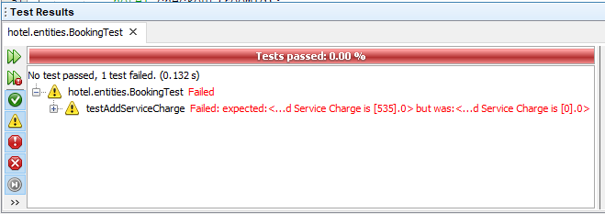

**Source code screenshot:**

In the following screenshots the error is highlighted. At present, addServiceCharges() method only store the service type not the cost as output displays the only service type however service cost is **$0.00**.

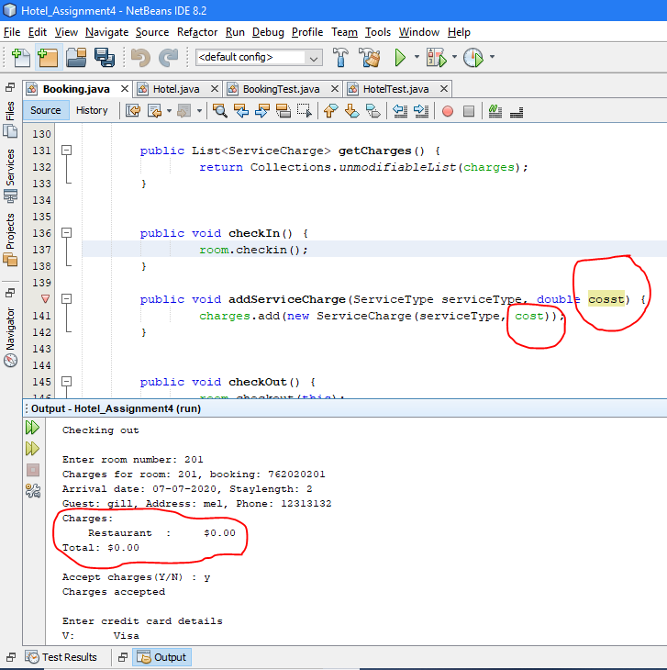

**5.2 Second reported bug: It is possible to charge a room for service after checked out.**

**The normal flow is required to display no booking present for the specific room at record services for the guest who has checked out.**

The method implementation is not correct that is why the room is still showing active after checked out however it needs to be removed from the active list and the unit testing result is also failed because of the same reason.

**Unit test output:**

The test result is failed because of the buggy behaviour as the checkout method is not removing the room from the active list that is why testFindActiveBookingByRoomID() method still showing room is active because of test is failed as expected and actual result is different.

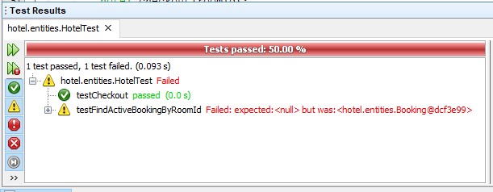

**Source code screenshot:**

In the following screenshots the error is highlighted. At present, checkout() method does not remove the room from the active booking list as checkin() method add(put) the room in the active list that is why it is possible to charge for any services after the guest has checked out as the room never remove from the active list.

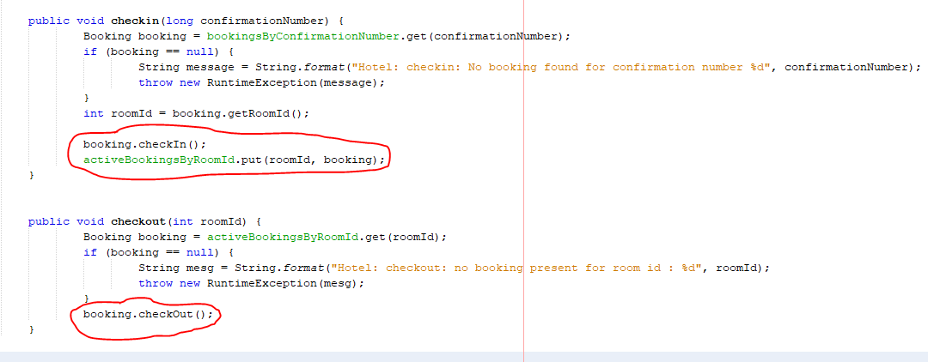

1. Key Scenarios
   1. Successful book a room.
   2. Successful check in.
   3. Unsuccessful record services.

* Does not passing the entered cost value to the required method for storing process.
  1. Unsuccessful check out.
* Does not remove the room from the active list.